**Experiment: 1.1**

**Student Name:** SANJIV GUPTA **UID:** 21BCS-*3478*

**Branch:** CSE **Section/Group:** 21BCS-IOT-602B

**Semester:** 5th **Date:** 17/08/23

**Subject Name**: IoT Lab **Subject Code:** 21CSP-344

**AIM:** *To Assemble Arduino Uno with the system and perform necessary software installation.*

**Objectives:**

*1. To study hardware and software related to IoT*

*2. To understand the function of Arduino Uno and other controllers.*

**Components Used:**

1. *Arduino Uno*
2. *Connecting Cable*
3. *Arduino Ide*

**Theory:**

**Arduino Board**

*Arduino Board: Arduino boards are open-source microcontrollers used for creating electronic projects. They have digital and analog pins for connecting sensors and devices. You program them using the Arduino IDE and the C++ language*

## **Features:**

* + *Microcontrollers for processing.*
  + *Digital and analog pins for connecting devices.*
  + *Programmed using Arduino IDE with C++.*
  + *Supportive community and libraries.*
  + *Various models for different needs.*

## **Pins:**

* + ***Digital Pins:*** *Input/output for digital signals (0 or 1).*
  + ***Analog Pins:*** *Input for analog signals (continuous range of values).*
  + ***Power Pins:*** *Provide power to the board (5V, 3.3V, GND).*
  + ***Communication Pins*:** *Transmit and receive data (UART, SPI, I2C).*
  + ***Special Pins:*** *PWM (Pulse Width Modulation) for controlling analog-like output and other special functions.*

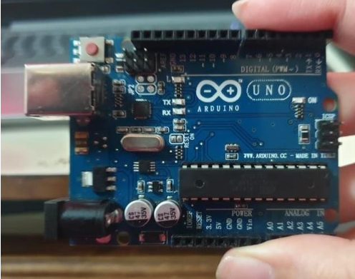 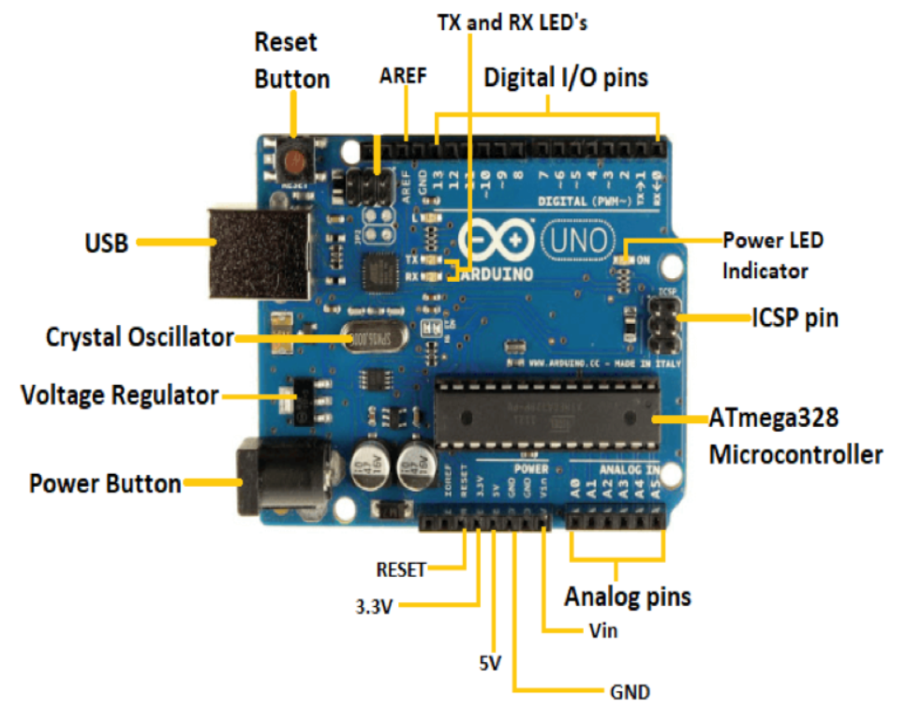

**Basic Adruino functions are:**

* ***digitalRead(pin):*** *Reads the digital value at the given pin.*
* ***digitalWrite(pin, value):*** *Writes the digital value to the given pin.*
* ***pinMode(pin, mode****): Sets the pin to input or output mode.*
* ***analogRead(pin):*** *Reads and returns the value.*
* ***analogWrite(pin, value):*** *Writes the value to that pin.*
* ***serial.begin(baud rate):*** *Sets the beginning of serial communication by setting the bit rate.*

**RASPERRY PI**

*Raspberry Pi is a compact, affordable computer board offering versatile features. It boasts GPIO pins for hardware interfacing, making it suitable for DIY electronics projects. With HDMI output, USB ports, and Wi-Fi capability, it supports coding, browsing, and multimedia tasks. Its low cost and diverse community make it a popular choice for learners and tinkerers.*

**Features**

* *Affordable single-board computer.*
* *HDMI output for connecting to displays.*
* *USB ports for peripherals like keyboards, mice, and storage.*
* *Wi-Fi and Ethernet connectivity options.*
* *Various operating systems, including Raspberry Pi OS (formerly Raspbian).*
* *Supports programming languages like Python, Scratch, and more.*

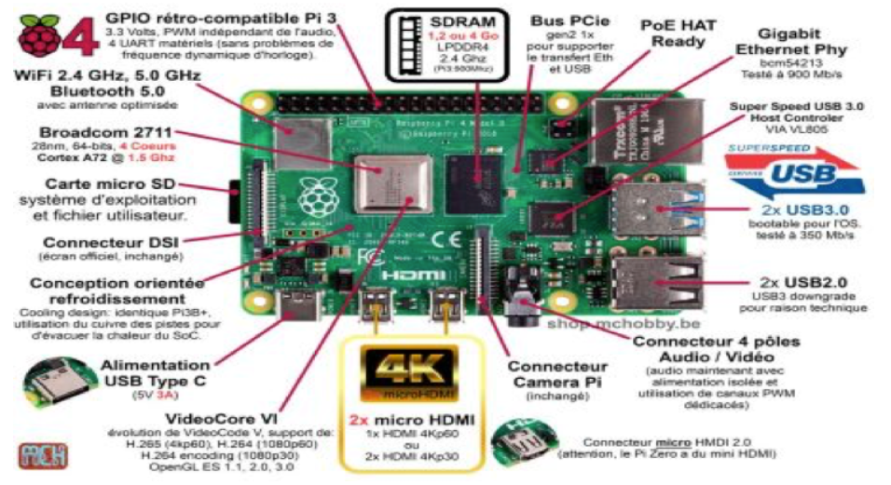

**Steps to install Arduino Ide:**

* *Visit Arduino.cc*
* *Select the ide and download it*
* *After downloading install the ide*
* *Now agree the required things which shown below:*

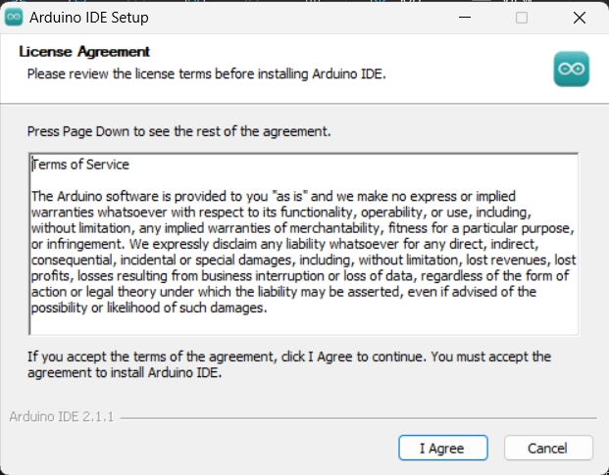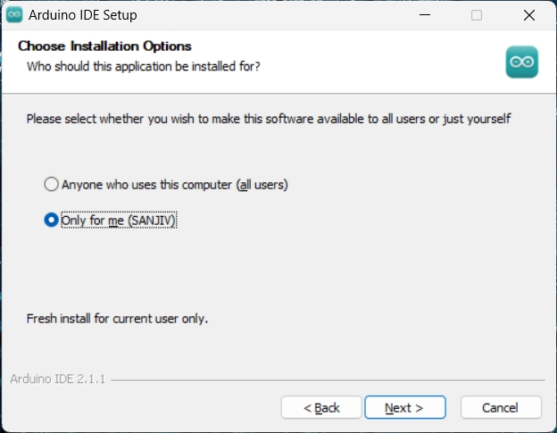

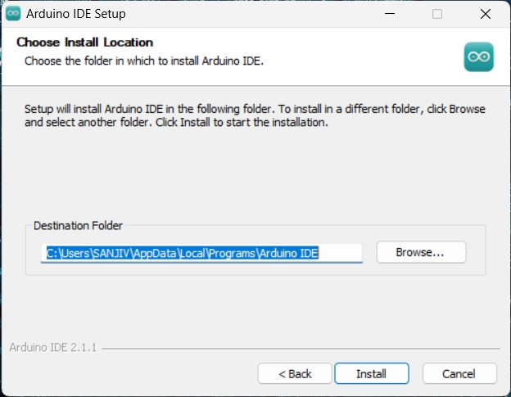 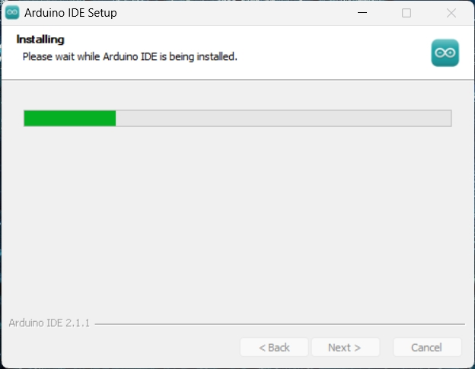 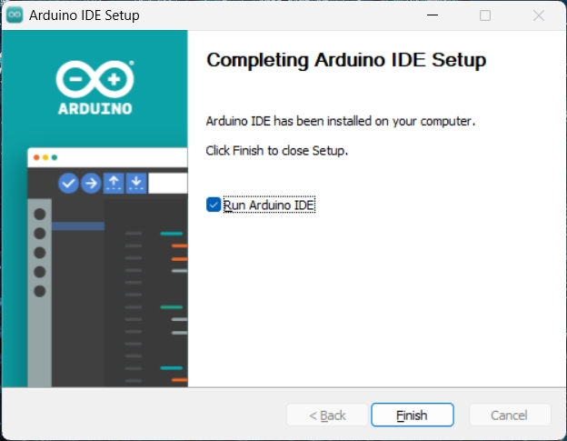 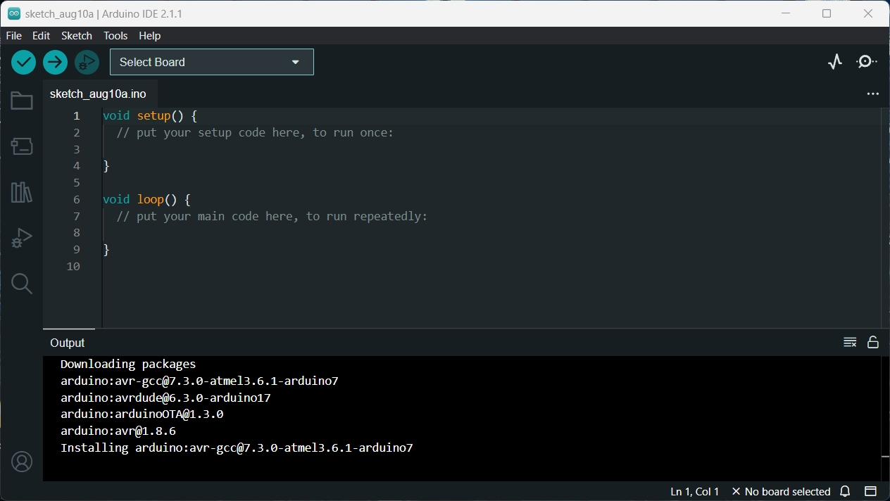 g

**Learning Outcomes:**